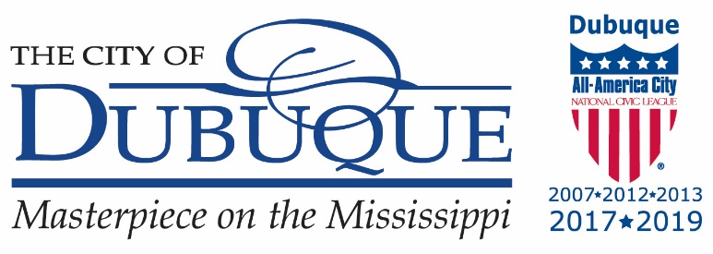

CITY OF DUBUQUE
PUBLIC MEETING NOTICE

Government Body: Human Rights Commission Subcommittee – DALWL Recommendation
Time: 10:00 AM Date: August 29, 2025
Place of Meeting: Multicultural Family Center
1157 Central Avenue
Dubuque, Iowa 52001

NOTICE IS HEREBY GIVEN that the above identified governmental body will meet at the time, date and place set forth above. The TENTATIVE AGENDA for the meeting is as follows:

- Roll Call
- New Business
  - Dubuque Area Land Water Legacy Resolution Recommendation
- Adjourn

This notice is given pursuant to Chapter 21, Code of Iowa, and applicable local regulations of the City of Dubuque and/or the governmental body holding the meeting.

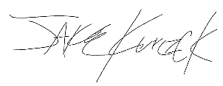

Jake Kurczek, Chairperson
Human Rights Commission

Join the meeting now
Meeting ID: 218 836 743 157
Passcode: RRc3Mb

Individuals with limited English proficiency should contact the Dubuque Human Rights Commission at (563)589-4190 at least 48 hours prior to the meeting. TTY/TRS users may dial 711 or 800-735-2942 (RELAY Iowa).

