City of Dubuque
COMMISSION MEETING MINUTES

GOVERNMENTAL BODY: Resilient Community Advisory Commission
DATE: July 25, 2017
TIME: 4:00 pm
LOCATION: Conference Room #1
City Hall Annex, 1300 Main St, Dubuque IA 52001

MEMBERS PRESENT: Dean Boles, Sara Booth, Ben Darr, Steve Drahozal, Stephanie Grutz, Robin Kennicker, Laura Roussell, Leah Specht. Absent: Carrie Lohrmann

STAFF PRESENT: Sustainable Community Coordinator Cori Burbach.

President Specht called the meeting to order at 4:05 p.m. Burbach confirmed that the meeting was in compliance with the Iowa Open Meeting Law.

PUBLIC COMMENT: No public comment.

RCAC STRATEGIC PLANNING SESSION. The Commission reviewed the RCAC strategic planning priorities as discussed and updated at the July 6, 2017 meeting. Following brief discussion, Kennicker moved and Darr seconded, to approve the strategic priorities document, and asked that the document be forwarded to the City Council by President Specht. The motion passed unanimously. (Note: Strategic priorities document is included in these minutes.)

COMMISSIONER REPORTS: No commissioner reports.

NEXT MEETING: Thursday August 3, 2017, 5:00 PM at City Hall Annex.

ADJOURNMENT: Darr moved, and Kennicker seconded, to adjourn at 4:20 pm. The motion passed unanimously.

Minutes approved by:
Leah Specht, Commission President

Prepared by:
Cori Burbach, Sustainable Community Coordinator

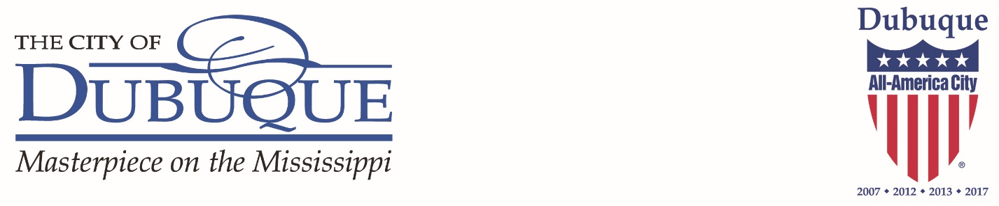

The Resilient Community Advisory Commission (RCAC) held their strategic planning session on Thursday, June 1, 2017.

As defined by a community engagement process completed in 2016, resiliency is: “the ability of individuals and systems to prevent, prepare for, and recover from adverse vulnerabilities while adapting to long-term changes.”

Given that framework, the Commission identified the following priorities for FY2018 (not in priority order). The Commission will seek opportunities to achieve these goals by a) reviewing research, data, and policy recommendations in order to advise City Council, b) educating and engaging the public on commission priorities, and/or c) partnering with other boards, commissions, or organizations to achieve identified goals.

1. Climate Change: The RCAC seeks to play a role in advising the City Council regarding climate mitigation and adaptation strategies.
a. Climate Mitigation: The 50% by 2030 Community Climate Action & Resiliency Plan, adopted by City Council in 2013, is the primary lens through which to prioritize climate mitigation actions.
- The RCAC recommends the City Council prioritize regular updates to the community GHG inventory to remain vigilant about achieving the 50% by 2030 goal. Best practices indicate this should be done every three years.
- The RCAC will review the 50% by 2030 plan in FY18, and advise City Council regarding future opportunities and recommendations.

b. Climate Adaptation: Climate adaptation can be defined as adjustments of a system to reduce vulnerability and increase the resiliency of the system in the face of climate change.
- The RCAC recommends staff education and community engagement to increase understanding of effects of climate change in Dubuque. In the fall of 2018, the City of Dubuque will receive a final Municipal Climate Adaptation Report as a result of its participation in a University of Nebraska Lincoln project funded by the National Oceanic and Atmospheric Administration (NOAA).
- The RCAC will lead implementation of the Design and Resiliency Team (DART) technical assistance program with the goal of creating a roadmap which will be used to incorporate climate adaptation strategies into existing and future plans and initiatives in our community.

2. Economic Resiliency Through Combatting Poverty & Increasing Social Capital: Creating an economically resilient community with a variety of quality, living wage jobs is a priority of the RCAC. Increasing poverty rates in Dubuque may result in increased stresses on service providers, impacts on the education system, and other negative consequences.

Increasing social capital in neighborhoods and resident engagement with government has been shown to increase community resiliency.
- The RCAC recommends increasing methods for sharing information regarding City programs and policies with the public that reach out to all demographics, and increasing opportunities for community engagement with local government.
- The RCAC recommends the City Council use an equity lens to examine economic development programs; improve upon strategic partnership to decrease poverty; prioritize exploration of strategies to increase the number of living wage jobs; and consider the impact City programs that support affordable housing, community planning, and youth programming could have on poverty prevention.
- The RCAC will explore methods for measuring social capital and identifying the City’s role in building this critical component of community resiliency.

3. Healthy Community: The RCAC supports City efforts to improve the health of the community. Specifically, the Commission advises the City Council to prioritize the following:
- The RCAC recommends City Council identify policies that can create a built environment where residents can make healthy choices.
- The RCAC recommends City Council support initiatives and programs that increase access to affordable, healthy, locally-grown food.
- The RCAC recommends City Council partner with relevant organizations to increase access to health services, especially mental health services.
- The RCAC recommends City Council utilize an equity lens to ensure that all residents have access to healthy natural and built environments and health services.

4. Improved Transparency & Performance Measurement: The RCAC advises the City Council to continue efforts to increase transparency in local government operations and transition to a more outcomes-based decision-making body.
- The RCAC recommends that City Council identify a shared set of leading outcomes that monitor community-level outcomes and indicators in order to track the economic, environmental, and social/cultural health of our community. The RCAC will provide input on the development of these outcomes and use the data to inform future work.
- The RCAC recommends that City Council develop an open data policy to ensure public access to information regarding municipal operations and long-term community outcomes.
- The RCAC will work with other commissions and the City Manager to pursue areas where data gaps are identified.

5. RCAC Development: The Resilient Community Advisory Commission is still in its infancy and will work in FY2018 to identify ways to effectively advise the City Council, communicate with other commissions, and provide input to City staff.
- The RCAC will utilize the STAR Community Rating in order to advise the City Council regarding policies and actions to create a more sustainable and resilient community.
- The RCAC will identify processes to provide meaningful input to City Council during the annual budget process and to boards and commissions with cross-representation on RCAC.
- The RCAC will share information about its priorities and actions with other commissions, partners, and community groups.

