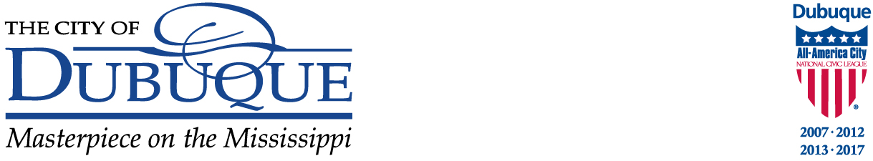

Date: ______________,__ 20__

To: CONTRACTOR NAME Engineering Department ADDRESS 50 W. 13th Street
CITY, STATE ZIP Dubuque, IA 52001
(563) 589-4270

notice of award

RE: ________________________________________ Project

Dear: _________________:

We are pleased to inform you that on ________________,________, 20________ you were awarded this Contract by the City of Dubuque in the amount of $__________.

In accordance with the requirements of the bid documents:
- Enclosed are three (3) copies of the Public Improvement Contract and Bond for the Project. Execute all copies and return them to the Engineering Department along with the following documents within ten (10) calendar days of the date for this Notice of Award.
- A certificate of liability insurance must be provided to the City along with the contract and bonds. The City of Dubuque insurance minimums and the specific requirements for the submission of the insurance documents are summarized in the Contract Documents Manual. Please forward this information to your insurance provider and work with them to ensure that proper limits and forms of coverage are provided.
- Complete and return the Project Information Requirements for State of Iowa Sales Tax Exemption Certificates for Contractors and Subcontractors form.

You will receive the Notice to Proceed once both parties have signed the contract for the _________________________________________ Project.

If you have any questions on this matter, please contact me at 563.589.4270.

Sincerely,

Name
Title
Enclosures

